**How it was Solved**

Q 23) Calculate the t scores of 95% confidence interval, 96% confidence interval,

99% confidence interval for sample size of 25

1. T score of 95% confidence interval is **1.711**

T score of 96% confidence interval is **2.064**

T score of 99% confidence interval is **3.467**

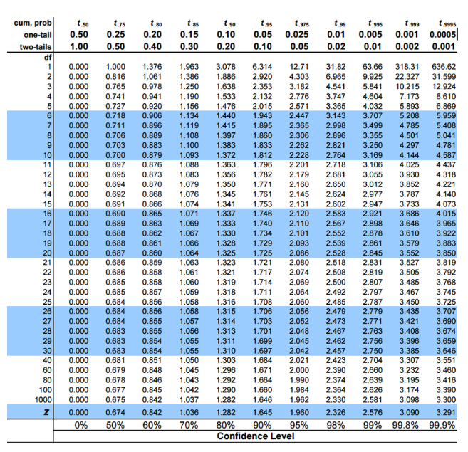

sample size of 25 i.e., n

T score of 95% confidence interval

Degrees of freedom = n – 1

= 25-1 🡺 24

By looking the table at 24 take the **tc_95** value

Same for the 96 and 99%